DIVINE SECONDARY SCHOOL KITALA

UGANDA NATIONAL LOWER SECONDARY

END OF TERM II EXAMINATION 2024

***S.2 CHEMISTRY***

***TIME: 2 ½ HOURS***

***NAME ……………………………………………………………………………………………………………………………………………………………….SIGN……………………***

***INSTRUCTIONS TO STUDENTS***

***ATTEMPT ALL ITEMS***

***ITEM 1***

1. At Katosi landing site, residents use Lake Vitoria as their main source of water which provides water that is not clean enough for use. The leaders urged the government to setup a treatment plant in order to provide safe water. However, leaders were requested to employ a skilled resident who is acquainted with how water is made safe for use, stages involved in purification and the challenges the project may face in the town.

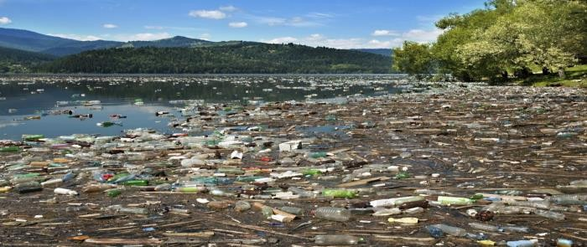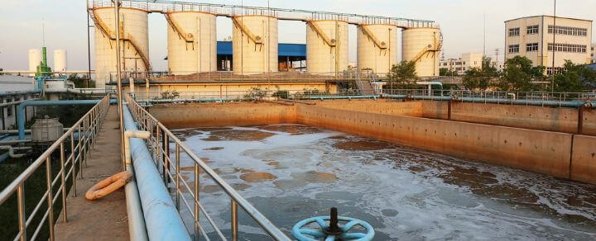

# TASK:

As a chemist ,provide the residents with the information they need to be employed.(15 scores)

…………………………………………………………………………………………………………………………………………………………………………………………………………………………………………………………………………………………………………………………………………………………………………………………………………………………………………………………………………………………………………………………………………………………………………………………………………………………………………………………………………………………………………………………………………………………………………………………………………………………………………………………………………………………………………………………………………………………………………………………………………………………………………………………………………………………………………………………………………………………………………………………………………………………………………………………………………………………………………………………………………………………………………………………………………………………………………………………………………………………………………………………………………………………………………………………………………………………………………………………………………………………………………………………………………………………………………………………………………………………………………………………………………………………………………………………………………………………………………………………………………………………………………………………………………………………………………………………………………………………………………………………………………………………………………………………………………………………………………………………………………………………………………………………………………………………………………………………………………………………………………………………………………………………………………………………………………………………………………………………………………………………………………………………………………………………………………………………………………………………………………………………………………………………………………………………………………………………………………………………………………………………………………………………………………………………………………………………………………………………………………………………………………………………………………………………………………………………………………………………………………………………………………………………………………………………………………………………………………………………………………………………………………………………………………………………………………………………………………………………………………………………………………………………………………………………………………………………………………………………………………………………………………………………………………………………………………………………………………………………………………………………………………………………………………………………………………………………………………………………………………………………………………………………………………………………………………………………………………………………………………………………………………………………………………………………………………………………………………………………………………………………………………………………………………………………………………………………………………………………………………………………………………………………………………………………………………………………………………………………………………………………………………………………………………………………………………………………………………………………………………………………………………………………………………………………………………………………………………………………………………………………………………………………………………………………………………………………………………………………………………………………………………………………………………………………………………………………….

ITEM 2

1. Most of the youths in Muwangi village in eastern Uganda are involved in cutting trees, burning the wood and the final products for cooking. Residents are frustrated with toxic fumes from the activities. They are curious and beseech to know the nature and composition of the product and why the activities.

The chairperson has contacted you as a chemistry learner for guidance on what she is about to communicate in the community meeting.

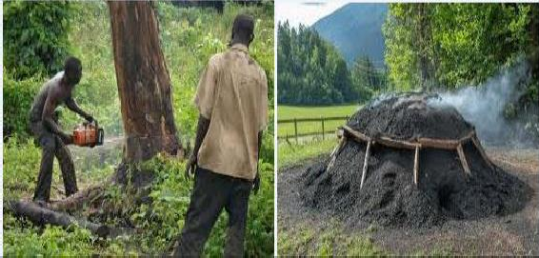

## Tasks;

* 1. Guide the chairperson on;
     1. Nature of the product.(01 score)

………………………………………………………………………………………………………………………………………

* + 1. Composition of the product.(01 score)

…………………………………………………………………………………………………………………………………………………………………………………………………………………………………………………………………........

* 1. Her concern is„‟cant these activities have any impact to their community? ,if so can this impact be reduced? Advise her(06 scores)

………………………………………………………………………………………………………………………………………………………………………………………………………………………………………………………………………………………………………………………………………………………………………………………………………………………………………………………………………………………………………………………………………………………………………………………………………………………………………………………………………………………………………………………………………………………………………………………………………………………………………………………………………………………………………………………………………………………………………………………………………………………………………………………………………………………………………………………………………………………………………………………………………………………………………………………………………………………………………………………………………………………………………………………………………………………………………………………………………………………………………………………………………………………………………………………………………………………………………………………………………………………………………………………………………………………………………………………………………………………………………………………………………………………………………………………………………………………………………………………………………………………………………………………………………………………………………………………………………………………………………………………………………………………………………………………...................................................

* 1. „‟Can the product benefit the residents?‟‟Take her through(5 scores)

…………………………………………………………………………………………………………………………………………………………………………………………………………………………………………………………………………………………………………………………………………………………………………………………………………………………………………………………………………………………………………………………………………………………………………………………………………………………………………………………………………………………………………………………………………………………………………………………………………………………………………………………………………………………………………………………………………………………………………………………………………………………………………………………………………………………………………………………………………………………………………………………………………………………………………………………………………………………………………………………………………………………………………………………………………………………………………………………………………………………………………………………………………………...

***SECTION B***

***ITEM 3***

In a certain school, the latrine is near senior three class. The foul smell disturbs the students in the class and the smell becomes much more on the hot day.

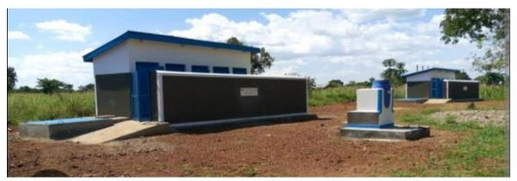TASK

* 1. Explainbrieflyhowthesmellmoleculesareabletomovefromthelatrineupto the classroom.
  2. Explain why the smell from the latrine become much more during the hot day.(15 SCORES)

ITEM 4

Nanyonjo Zahara is a student in BuwengeCollegeinJinjadistrict.Wheninthe chemistryclass,Mr.NgamboWilsonetaughtherthatmeltingofcandlewaxwhena candle is burning is a physical change. The teacher told them to go and research more from a particular book in the library about chemical and physical changes. On reading the book, she found that a burning candle has both physical and chemical changes. Zahara wondered which chemical change is in the burning candle since their teacher had only said that a burning candle has only physical change. When she went back home, she saw the uncle splitting firewood into small pieces. At the same time, her mother was using the splitted pieces of wood to cook food.

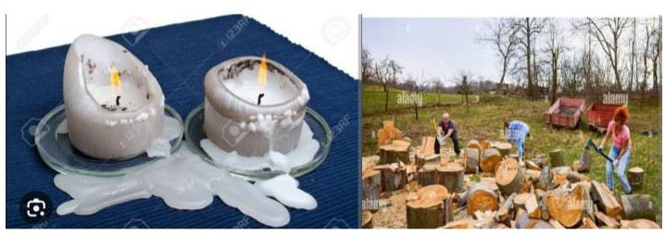

**Task.**Write a message to Zahara sensitizing her in her research about the various chemical and physical changes to present to their teacher.(15 SCORES )

**…**……………………………………………………………………………………………………………………………………………………………………………………………………………………………………………………………………………………………………………………………………………………………………………………………………………………………………………………………………………………………………………………………………………………………………………………………………………………………………………………………………………………………………………………………………………………………………………………………………………………………………………………………………………………………………………………………………………………………………………………………………………………………………………………………………………………………………………………………………………………………………………………………………………………………………………………………………………………………………………………………………………………………………………………………………………………………………………………………………………………………………………………………………………………………………………………………………………………………………………………………………………………………………………………………………………………………………………………………………………………………………………………………………………………………………………………………………………………………………………………………………………………………………………………………………………………………………………………………………………………………………………………………………………………………………………………………………………………………………………………………………………………………………………………………………………………………………………………………………………………………………………………………………………………………………………………………………………………………………………………………………………………………………………………………………………………………………………………………………………………………………………………………………………………………………………………………………………………………………………………………………………………………………………………………………………………………………………………………………………………………………………………………………………………………………………………………………………………………………………………………………………………………………………………………………………………………………………………………………………………………………………………………………………………………………………………………………………………………………………………………………………………………………………………………………………………………………………………………………………………………………………………………………………………………………………………………………………………………………………………………………………………………………………………………………………………………………………………………………………………………………………………………………………………………………………………………………………………………………………………………………………………………………………………………………………………………………………………………………………………………………………………………………………………………………………………………………………………………………………………………………………………………………………………………………………………………………………………………………………………………………………………………………………………………………………………………………………………………………………………………………………………………………………………………………………………………………………………………………………………………………………………………………………………………………………………………………………………………………………………………………………………………………………………………………………………………………………………………………………………………………………………………………………………………………………………………………………………………………………………………………………………………………………………………………………………………………………………………………………………………………………………………………………………………………………………………………………………………………………………………………………………………………………………………………………………………………………………………………………………………………………………………………………………………………………………………………………………………………………………………………………………………………………………………………………………………………………………………………………………………………………………………………………………………………………………………………………………………………………………………………………………………………………………………………………………………………………………………………………………………………………………………………………………………………………………………………………………………………………………………………………………………………………………………………………………………………………………………………………………………………………………………………………………………………………………………………………………………………………………………………………………………………………………………………………………………………………………………………………………………………………………………………………………………………………………………………………………………………………………………………………………………………………………………………………………………………………………………………………………………………………………………………………………………………………………………………………………………………………………………………………………………………………………………………………………………………………………………………………………………………………………………………………………………………………………………………………………………………………………………………………………………………………………………………………………………………………………………………………………………………………………………………………………………………………………………………………………………………………………………………………………………………………………………………………………………………………………………………………………………………………………………………………………………………………………………………………………………………………………………………………………………………………………………………………………………………………………………………………………………………………………………………………………………………………………………………………………………………………………………………………………………………………………………………………………………………………………………………………………………………………………………………………………………………………………………………………………………………………………………………………………………………………………………………………………………………………………………………………………………………………………………………………………………………………………………………………………………………………………………………………………………………………………………………………………………………………………………………………………………………………………………………………………………………………………………………………………………………………………………………………………………………………………………………………………………………………………………………………………………………………………………………………………………………………………………………………………………………………………………………………………………………………………………………………………………………………………………………………………………………………………………………………………………………………………………………………………………………………………………………………………………………………………………………………………………………………………………………………………………………………………………………………………………………………………………………………………………………………………………………………………………………………………………………………………………………………………………………………………………………………………………………………………………………………………………………………………………………………………………………………………………………………………………………………………………………………………………………………………………………………………………………………………………………………………………………………………………………………………………………………………………………………………………………………………………………………………………………………………………………………………………………………………………………………………………………………………………………………………………………………………………………………………………………………………………………………………………………………………………………………………………………………………………………………………………………………………………………………………………………………………………………………………………………………………………………………………………………………………………………………………………………………………………………………………………………………………………………………………………………………………………………………………………………………………………………………………………………………………………………………………………………………………………………………………………………………………………………………………………………………………………………………………………………………………………………………………………………………………………………………………………………………………………………………………………………………………………………………………………………………………………………………………………………………………………………………………………………………………………………………………………………………………………………………………………………………………………………………………………………………………………………………………………………………………………………………………………………………………………………………………………………………………………………………………………………………………………………………………………………………………………………………………………………………………………………………………………………………………………………………………………………………………………………………………………………………………

***ATTEMPT ITEM 3 ON THIS PAGE***